# **Installation Process**

First download and install the setup of VMWare Workstation.

Then visit following link for installing ISO file for Ubuntu.

Link: <https://releases.ubuntu.com/18.04/>

Install the following file:



Once the VMWare Workstation is installed, we need to create a virtual machine.

Launch VMWare Workstation. Click on **“Create a New Virtual Machine”**

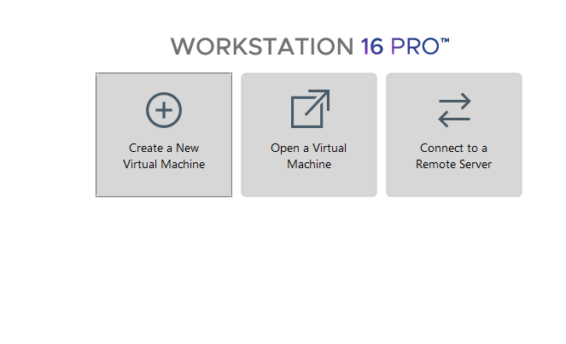  
Choose the **Custom (Advanced)** option.

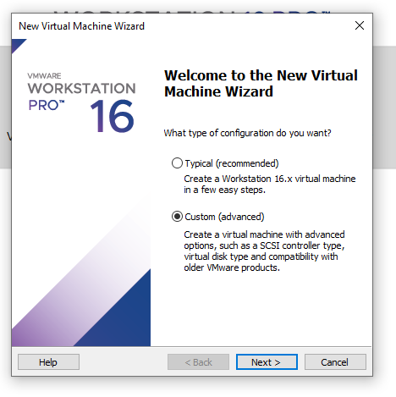

Keep the default settings and click **Next** until you reach here. Now, browse the location of that Installer Disc Image (iso) file that you downloaded earlier and again hit **Next**.

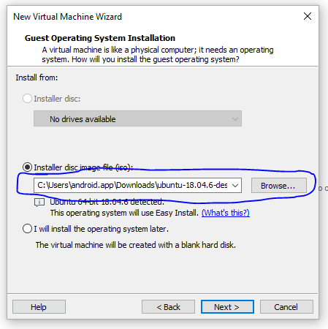

Now, provide a user name and a suitable password for this virtual machine. It will ask for the password every time you power on this virtual machine.

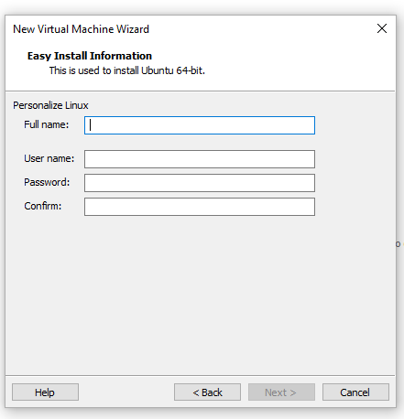

Then keep clicking the next button, until you reach this screen. Make sure the number of processors assigned to machine is at least 2.

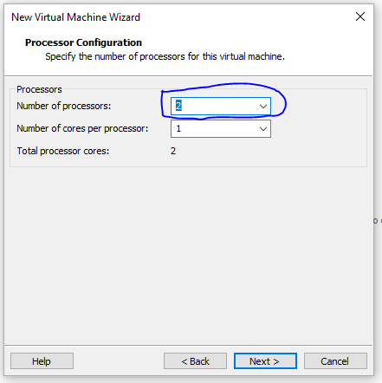

Make sure to assign the recommended memory space to virtual machine i.e. 2 GB (2048 MB).

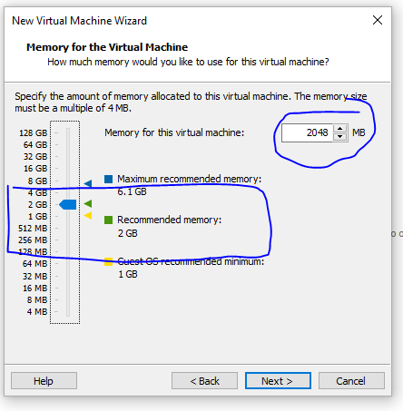

Again, keep clicking **Next** button until you see following screen. Make sure to select second option which says ***Split Virtual Disk into Multiple Files***. Also, assure that at least 20 GB of memory space is assigned.

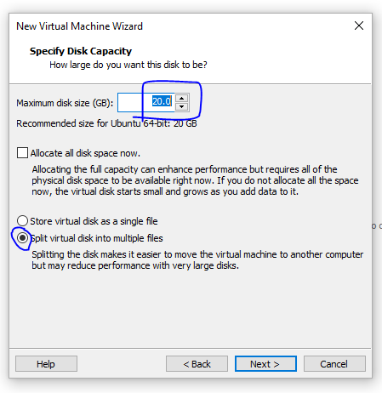

Keep the rest of the settings at default and proceed until you see the following screen. Click the finish button and your machine will be created.

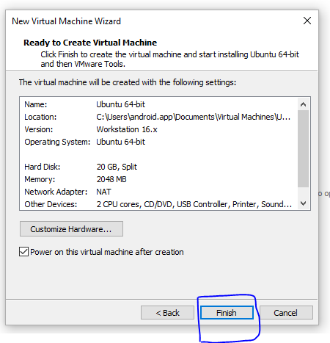

It will take a while to create machine and install all required things. Then you will see your machine created at the left side-bar.

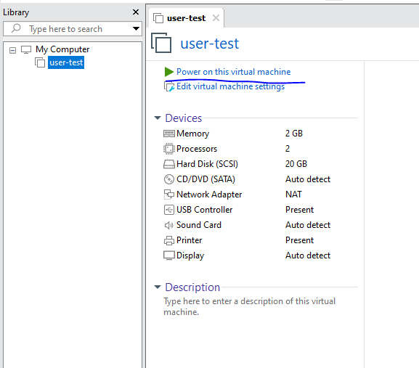

Power on the virtual machine and enter the password. You will then be all set to start working.